Name ___________________________________________ Date ___________

c.16 Trace Evidence Vocabulary

1. Polarized Light Microscope

2. Stereo Binocular Microscope

3. Microspectrophotometry

4. Compound Binocular Microscope

5. Polarized Light Microscope (p. 318)

6. Refractive Index (RI)

7. Transfer Evidence

8. Becke Line

9. Medulla

10. Cortex

11. Cuticle

12. Draw and identify the 3 parts of a strand of hair:

13. Name and describe the types of cracks from broken glass:

14. Identify the microscope used to analyze paint samples:

15. Name 3 physical characteristics of soil that are relevant to proper identification:
Compound Light Microscope – textbook page 317 will help with some of these
1. _____________________
3. _____________________
____x
____x
____x
2. ______________________
6. _____________________
5. _____________________
4. _____________________
10. __________________
9. ___________________
8. ____________________
7. ____________________
12. ___________________
____x
11.____________________
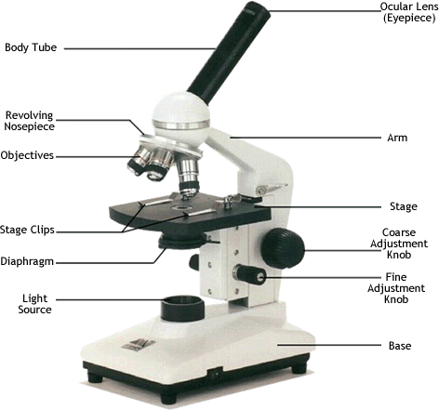
http://www.biologycorner.com/microquiz/index.html

Answer the following questions referring to pages 316 -324 in your textbook.
Put your answer to these 3 questions in your notes. These are 3 VERY IMPORTANT questions for the unit.
- List and explain the 9 characteristics of a microscope (see figure 16.2, p. 318).

- Identify the 6 characteristics of light.
- What is the difference between normal light and plain polarized light?

